DRAFT

SE SWCD TECH. SUPPORT JPB MEETING AGENDA
January 31, 2017

LOCATION: MN Pollution Control Agency Conference Room
18 Woodlake Drive SE
Rochester, MN 55904

TIME: 9:30 AM – Noon

AGENDA

INTRODUCTIONS AND BACKGROUND

ORGANIZE JPB FOR 2017

- Election of Officers (2016 Officers listed below; have served 2 years)
- Chairperson (Paul Heers, Jr., Freeborn SWCD, incumbent)
- Vice Chair (Larry Scherger, Dodge SWCD, incumbent)
C. Treasurer (John Jaeger, Goodhue SWCD, incumbent)
D. Secretary (Not elected, Host District Manager)

- Appointment of all Committees (Chairperson)
- Finance Committee (see attached sheet)
- Personnel Committee (see attached sheet)
- Prioritization Committee (see attached sheet)
- Executive Committee (see attached sheet)

SECRETARY’S REPORT

- Approve Minutes of July 27, 2016 Regular Meeting (see Attached).
- Action to Affirm Executive Committee Actions from December 7, 2016.

COMMITTEE REPORTS

- Personnel Committee (January 25, 2017)
- Finance Committee: (Did not meet – Fiscal year ends June 30 2017.)
- Executive Committee Meeting: December 7 2016.
- TSA and Local JPB Reorganization Update.
- Supplemental Grants
A. Nutrient Management Grant Update
Fillmore & Rice SWCDs.
B. Nitrogen BMP Grant Update
C. CWF2013 Technical Grant Update
i. JPB Engineering Staff
ii. Feedlot Techs: Dodge & Wabasha
D. Soil Health Grant Update
E. LCCMR Cover Crop Grant
F. MN Ag Water Quality Certification Program
G. RCPP Grant: Lower Mississippi River Feedlot Management

ACTION ITEMS

1. Approve Committee Reports and Act on Recommendations
- Personnel Committee
A. Approve 2017 Wage Scale with Cost of Living Increase.
B. Action on JPB Staff Salary Step.
i. Pete Fryer:
ii. Jason Rochester,
iii. Kate Bruss
iv. Chris Nelson
- Health Insurance Recommendation
- Job Description Change: Chris Nelson
- Equipment / Software Recommendation

- Action to Approve Fiscal Year 2016 Financial Audit when Complete.
- Action on 2018 Enhanced Shared Technical Services, Part 2 P16-8844, $115,000 Grant (Requires 25% local match, 10% of which must be local Cash).
- Action on Administrative Costs / Dues Recommendation for 2017
- Action to Authorize JPB to Sign RCPP Grant Agreements and Sub Agreements.
- Authorize Exploration of Option B Shared Administration with the SE Water Resources Board.
- Other

REPORTS

- Other.

ADJOURNMENT
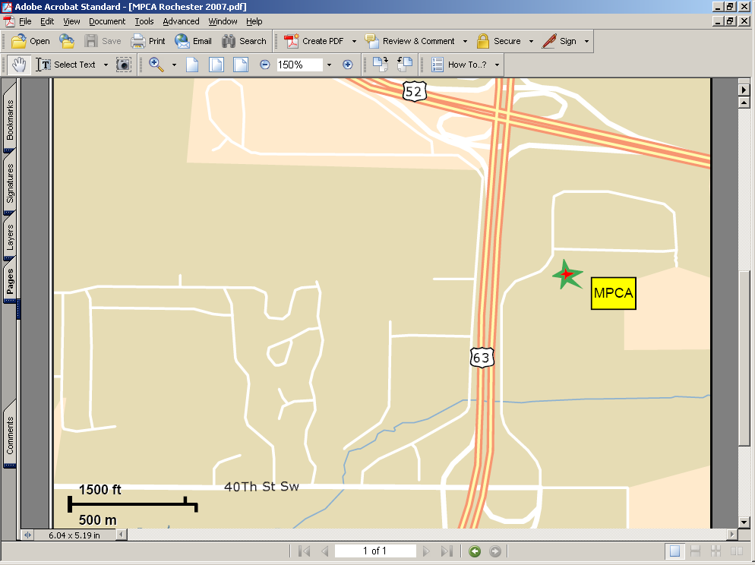
(south side of Rochester, across road from old Fleet Farm store. Exit on 40th St SW.)
P:\SE SWCD JPB\Word Documents\SRF JPB Meetings (Full Board)\2017\jpb agenda January 31 2017.docx

