Special Meeting

SE SWCD TECH. SUPPORT JPB MEETING AGENDA
March 23, 2017

LOCATION: Olmsted SWCD Office Conference Room A
2122 Campus Drive SE
Rochester, MN 55904

TIME: 10:00 AM – Noon

AGENDA

INTRODUCTIONS

ACTION ITEMS

- Authorize Executive Committee to Meet Jointly with SE Water Resources Board Executive Committee to Discuss Shared Administration Options, April 5th, 2017 at 10:00 AM.
- Review and approve Minnesota Board of Water and Soil Resources Funding within the Regional Conservation Partners Program: Lower Mississippi River Feedlot Management in Minnesota Conservation Cost Share Policy.
- Action on whether or not to move forward with developing a policy of charging fees for technical assistance to landowners without cost share funding.
- Other

ADJOURNMENT

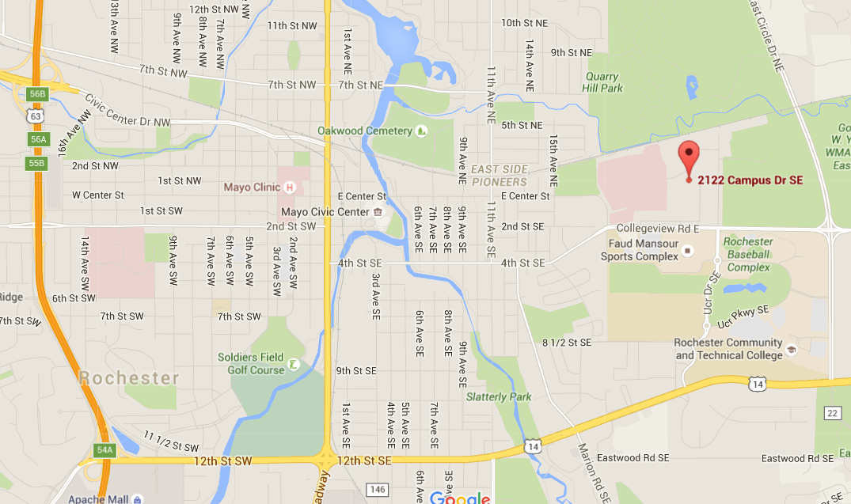

P:\SE SWCD JPB\Word Documents\SRF JPB Meetings (Full Board)\2017\jpb agenda March 23 2017 Special Meeting.docx

