SE SWCD TECH. SUPPORT JPB MEETING

Draft AGENDA
Tuesday, July 30 2019

LOCATION: PEOPLE’S ENERGY COOPERATIVE
1775 Lake Shady Ave. S.
Oronoco, MN

TIME: 9:30 AM – Noon

AGENDA

INTRODUCTIONS

III. SECRETARY’S REPORT
- Approve January 30, 2019 Minutes

COMMITTEE REPORTS
1. Finance Committee

ACTION ITEMS

Old Business:
1. Grant Updates:
A. RCPP Feedlot Grant
Current Projects (nearing end of Grants, focus cost sharing)
Final Grant Agreement with BWSR: $260,000
Final RCPP EQIP signup March 2020.
B. Enhanced Shared Technical Services Grants
Soil Health Position Supplemental Funding.
C. Other.

New Business:
- Review and Act on Finance Committee Recommendations.
- Action on Approval of Fiscal Year 2019 Financial Reports.
- Action on Fiscal Year 2020 Budget.
- Update: FY2020 BWSR Grant: NPEA Base Operations Funding & Enhanced Shared Technical Services (Chair Authorized to Sign via Resolution Approved at January 29 2015 Meeting).
- Action to Authorize Credit Cards for TSA Staff Expenses.
- Action on RCPP Small Feedlot Fix Program:
- Approve Sub Agreement with Dodge SWCD for new RCPP Feedlot Cost Share, Contingent on NRCS approval of EQIP Cost Share: for Currier Brothers, 90% Combined EQIP /State Cost Share plus Technical Funding.
- Decision on if JPB Should Fund Projects this Year @ 75% with just State Funds.
- Decision on How to Rank of eligible project for cost share.
- Deadline for Landowner to Sign Cost Share Agreement.
- Decision on Special Meeting or Executive Committee Meeting to Fund New Sub Agreements for Cost Share.
- Authorize Host Manager to Request Extension to RCPP Grant Agreement P17-4048; and to Sign 50% Financial Statement Allowing Request for next 40% Payment to JPB.
- Authorize Chair to Sign Final Grant Agreement for RCPP Feedlot, $260,000; expected September 2019.
- Authorize Financial Audit with Peterson Company LTD for FY2019: $3000.
- JPB Staff Equipment Update.
- Action on Final Financial Reports for BWSR Grants: Authorize JPB Secretary to Sign Grant Final Financial Reports.

- Action to Authorize JPB Application to BWSR Clean Water Funding For Construction of RCPP Feedlot Projects that Applied But Did Not Receive Funding.
- Other:

VI. PROJECT SUMMARY / REPORTS
1. BWSR Updates:
2. Bill Thompson, Area 7 Director:
3. Other

VII. ADJOURNMENT

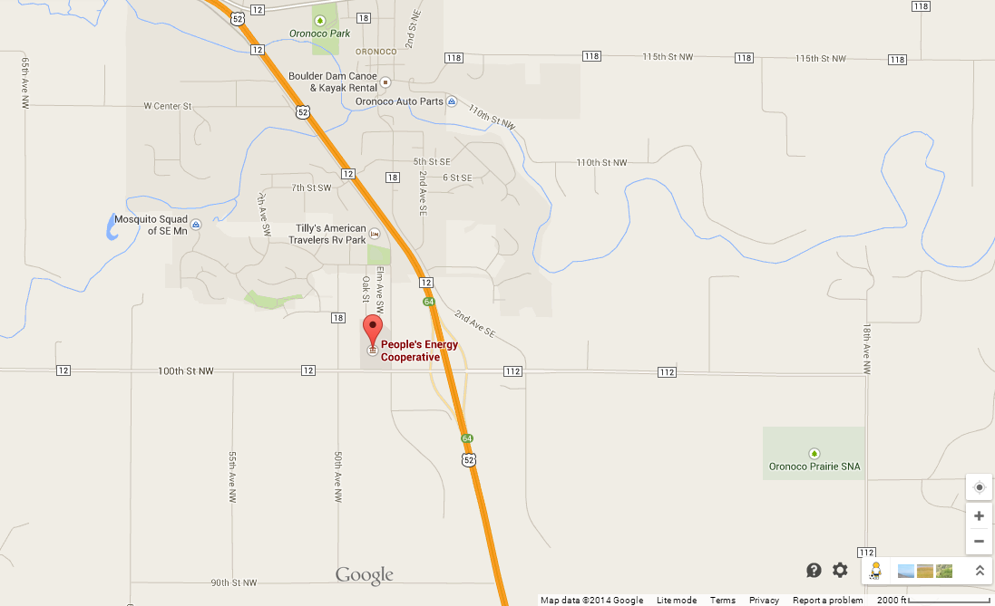

P:\SE SWCD JPB\Word Documents\SRF JPB Meetings (Full Board)\2019\jpb agenda July 30 2019.docx

